**Lesson03 Azure Lab Plan Service**

**Notes: -**

**1-on azure portal > create web app > select the azure subscription and resource group and select publish Code with select .Net framework 4.7**

**2-we also select the azure service plan with seeing 3-tab options**

**Dev/Test: Free (60 Min/day), shared (240 Min/day), Standard (unlimited)**

**(you can see the included hardware and included features)**

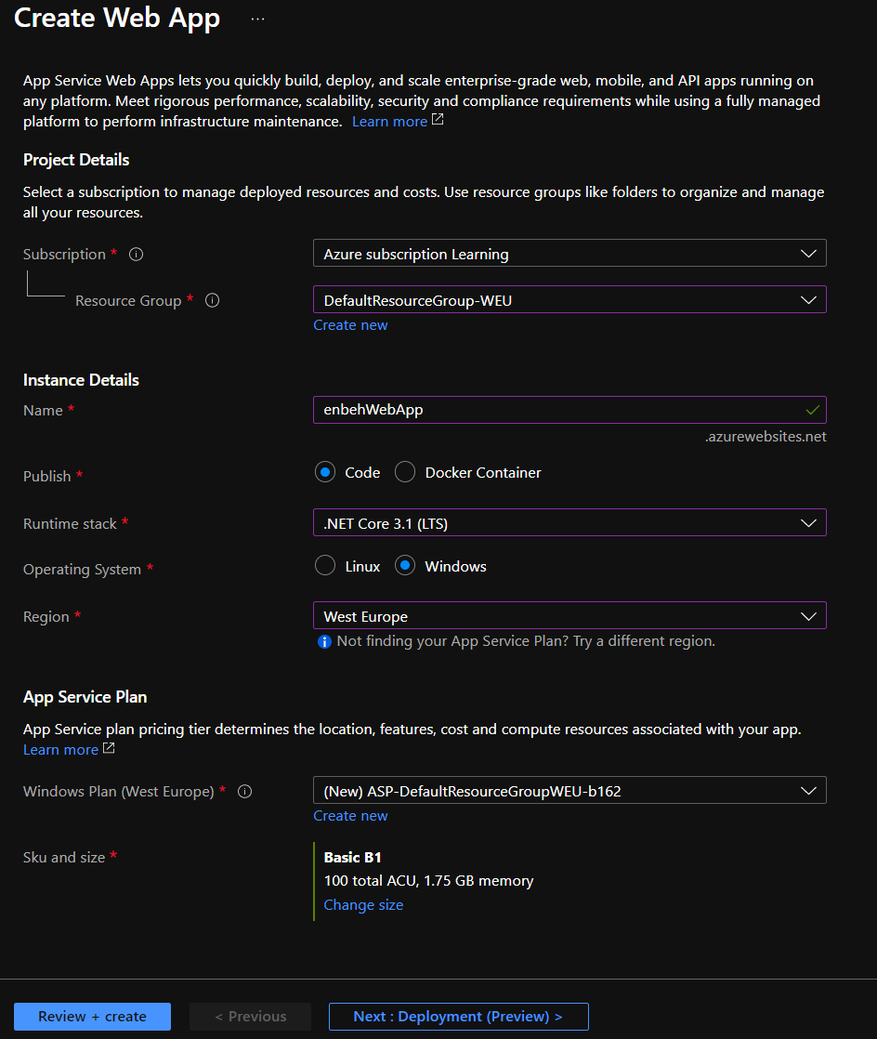

**3-we disable the application insight and set the tags to create the web app**

**4-on the Visual Studio > Publish > app service (select azure subscription, azure group)**

**5-you can see that the azure web app URL and app service plan as below**

**(copy and paste URL to check it)**

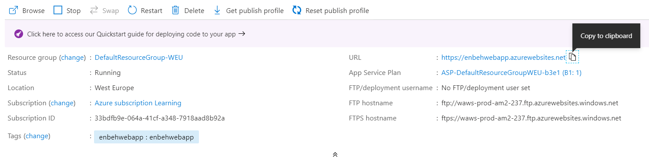

**6-on VS2019 > publish > select Azure App service**

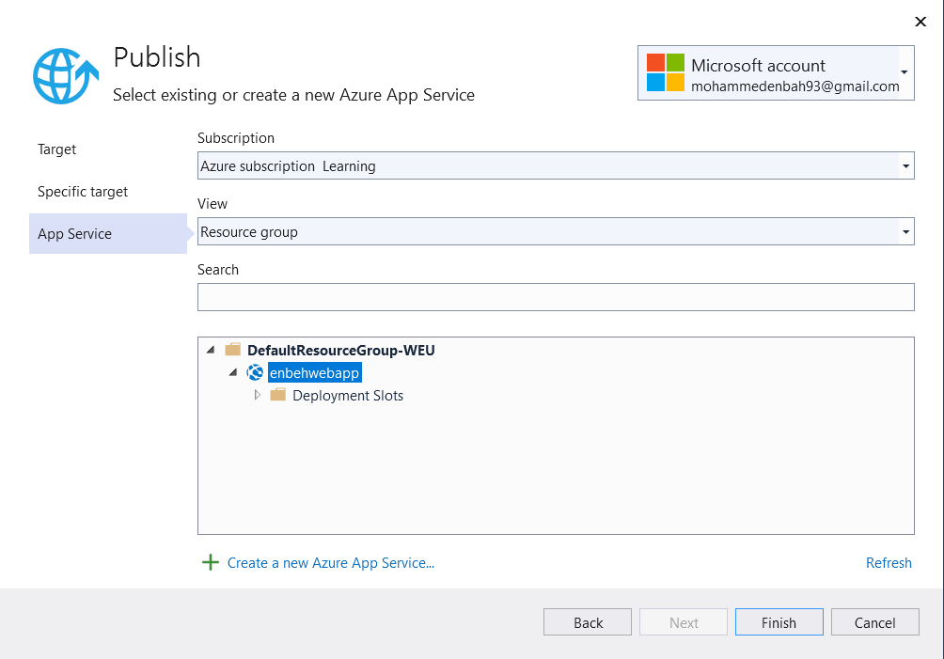

**7-browse the link again and you will see that it will see the result**

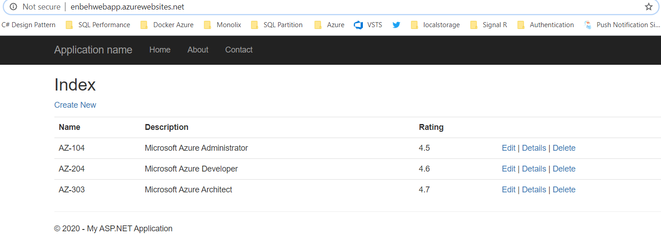

**8-we see that it will create the following resource**

**App Service**

**App Service Plan**

**Application Insight if enabled on creation**